PRODUCT NAME:
Femobiome 16 Multiplex qPCR Kit
INTENDED USE:
The Femobiome 16 Multiplex qPCR Kit allows, using one biological sample, to perform a quantitative assessment of the total bacterial load (TBL), urogenital normoflora - lactobacilli, complex of aerobic and anaerobic microorganisms, typical for the women's urogenital tract, mycoplasmas, fungi of the Candida genus, involved in the development of dysbiotic processes in urogenital microbiome composition.



Headquarters: Neighborhood of Dumlupınar, Nur St. No: 7/3 Post Code: 41250 Kartepe/Kocaeli/TURKEY
Branch: TUBITAK MAM Technology Free Zone, Neighborhood of Barıs SB, 5002 Street, New Tech. Building, Blok A, No: 4A/ Z09 Post Code: 41400
Gebze/Kocaeli/TURKEY
Trd Register Number: 34218
Email: info@genomer.com.tr
https://genomer.com.tr

Purpose
This document constitutes the Instructions for Use (IFU) for the Femobiome 16 Multiplex qPCR Kit, an In Vitro Diagnostic (IVD) medical device.
The European Union's In Vitro Diagnostic Medical Devices Regulation (IVDR) 2017/746 aims to ensure a high level of health and safety protection for patients and users throughout the entire lifecycle of the device.
These Instructions for Use have been prepared to fully satisfy all obligations stipulated under Annex I: General Safety and Performance Requirements of the IVDR, specifically within Chapter III: Information Supplied by the Manufacturer (Article 20).
The primary objective is to ensure the safe, accurate, and effective use of the device for its intended purpose. These instructions encompass all necessary technical, procedural, and legal information for laboratory professionals, including device performance, limitations, potential risks, and appropriate sample management.
Regulatory Compliance and Transparency
This guide not only employs pictograms and symbols strictly in accordance with national and international standards (specifically IVDR, EN ISO 15223-1, and EN ISO 18113) but also transparently presents all legally required device identifiers (UDI, Manufacturer, Authorized Representative).
Warning: It is imperative to read, understand, and meticulously adhere to these instructions in their entirety prior to using the device to ensure safe and accurate results. Failure to comply may lead to erroneous results, potential hazards, or invalidation of the CE marking.

I. DESCRIPTIVE INFORMATION
1. | Article  20.3(a), 20.4.1(b) | Device Name, Trade Name, and Model | Femobiome 16 Multiplex qPCR Kit
2. | Article 20.3(b) | In Vitro Diagnostic Device | The Femobiome 16 Multiplex qPCR Kit allows, using one biological sample, to perform a quantitative assessment of the total bacterial load (TBL), urogenital normoflora - lactobacilli, complex of aerobic and anaerobic microorganisms, typical for the women's urogenital tract, mycoplasmas, fungi of the Candida genus, involved in the development of dysbiotic processes in urogenital microbiome composition.
3. | Article 20.3(d) | Manufacturer Information | GENOMER BIOTECHNOLOGY R&D IND. TRD. LIMITED COMPANY,  Headquarters: Neighborhood of Dumlupınar, Nur St. No: 7/3 Post Code: 41250 Kartepe/Kocaeli/TURKEY  Branch: TUBITAK MAM Technology Free Zone, Neighborhood of Barıs SB, 5002 Street, New Tech. Building, Blok A, No: 4A/ Z09 Post Code: 41400  Gebze/Kocaeli/TURKEY  Trd Register Number: 34218  Email: info@genomer.com.tr  Web:https://genomer.com.tr
4. | Article 20.3(e) | Authorized Representative Information | Required only if the manufacturer is located outside the EU.
5. | Article 20.3(f) | Lot/Batch Number | UL-FB16-XX
6. | Article 20.3(g) | Expiry/Use-by Date | YYYY/AA/GG
7. | Article 20.3(c) | Catalog Number | M-FB16-0701v01-12
8. | Article 20.3(n) | Unique Device Identifier (UDI) Reference | 868512670MFB16G6
The results obtained in accordance with the procedures and analytical acceptance criteria specified in the aforementioned Instructions for Use (IFU) guide confirm the conformity of Femobiome 16 Multiplex qPCR Kit device with the General Safety and Performance Requirements (Annex I).

II. INTENDED USE, SCOPE, AND PRINCIPLE

9. | Article 20.4.1(c) | Intended Use and Function

The Femobiome 16 Multiplex qPCR Kit offers an in vitro nucleic acid based test. The test utilizes the Polymerase Chain Reaction (PCR) nucleic acid amplification technique aimed to detect opportunistic flora and normal flora in urogenital specimens.
The Femobiome 16 Multiplex qPCR Kit allows, using one biological sample, to perform a quantitative assessment of the total bacterial load (TBL), urogenital normoflora - lactobacilli, complex of aerobic and anaerobic microorganisms, typical for the women's urogenital tract, mycoplasmas, fungi of the Candida genus, involved in the development of dysbiotic processes in urogenital microbiome composition.
The microbiome state has a serious impact on the reproductive function and, as a result, on the quality of woman’s life. Diseases caused by opportunistic microflora may occur both with clinical manifestations and asymptomatically. The asymptomatic disease course often leads to late reference to doctor and development of serious complications. Diseases caused by opportunistic microorganisms increase the risk of infection with sexually transmitted infections and HIV infections. In time undiagnosed infections, associated with an opportunistic microflora, can cause abnormalities in the women reproductive function, spontaneous abortions, premature births, intrauterine infection and low fetal birth weight, postnatal complications, and complications after surgery intervention on the pelvic organs. The urgency of diagnostics of the opportunistic microflora associated infections of urogenital tract is in question. The diagnostic methods used in routine laboratory practice do not always allow the doctor to adequately assess the patient's condition and prescribe the necessary treatment. At the same time, the possibilities of the modern PCR laboratory allow to conduct the multifactorial quantitative studies, detecting the DNA of various microorganisms in the samples.
The application of the kit does not depend on population and demographic aspects. There are no contradictions for use of the Femobiome 16 Multiplex qPCR Kit.
The Femobiome 16 Multiplex qPCR Kit can be used in clinical and diagnostic laboratories of medical institutions and research practice.
Potential users: personnel qualified in molecular diagnostics methods and working in the clinical and diagnostic laboratory.
It is necessary to apply he kit only as directed in this instruction for use.

II. INTENDED USE, SCOPE, AND PRINCIPLE

10. | Article 20.4.1(e) | Test Principle - Method

The implemented PCR method is based on amplification of a target DNA sequence. To increase the sensitivity and specificity of the amplification reaction, the use of a hot-start is provided. Hot-start is provided by reaction mixture preparation consisting of two layers separated by a layer of paraffin or the use of Taq-polymerase blocked by antibodies. The polymerase chain reaction starts only when paraffin is melted or thermal dissociation of a complex of Taq polymerase and antibodies is happened. It excludes non-specific annealing of primers to targets DNA in the initial heating of the tube.
The Femobiome 16 Multiplex qPCR Kit is based on fluorescent modification of the PCR method. The PCR-mix contains two target-specific probes bearing reporter fluorescent dyes (Fam and Hex) and quencher molecules. Once hybridized to a target sequence, the probes become activated. As a result of activation fluorescence increases proportionally to target sequence amplification. The intensity of fluorescence is measured at every cycle of reaction with a Real-time PCR thermal cycler data collection unit and analyzed with the software provided.
The Femobiome 16 Multiplex qPCR Kit includes following components: PCR-mixes for total bacterial load amplification, PCR-mixes for Lactobacillus spp. amplification, PCR-mixes for opportunistic flora DNA amplification.
One tube (strip-2, tube №8) contains a PCR-mix for the amplification of human genomic DNA (sample intake control (SIC)). The SIC allows to exclude preanalytical error. If the amount of collected material is insufficient for the analysis, it is necessary to repeat sampling procedure.
One tube (strip-1, tube №2) contains an internal control (IC), which is intended to assess the quality of the polymerase chain reaction.
The fluorescent dyes are assigned to individual types of sequences. The Fam dye label is used to detect specific sequences. The Hex dye label is used to detect SIC and IC. Use of two distinguishable dyes allows detection of both PCR products simultaneously.
Defined tubes contain additional probe with Rox dye label – “Marker”. It tags the strip orientation. Upon completion of run, software defines actual position of the strip (by means of “marker” position) relative to the position preset by the operator. If it mismatches, the software suggests rearrangement of the tubes by default. In accordance with the operator, order can be rearranged and saved in new file.
Upon completion of the run, software performs relative quantitative analysis of total bacterial DNA, genus-specific DNA of Lactobacillus spp. and genus/species-specific DNA of each the opportunistic pathogens (or flora). To exclude false negatives, human DNA (SIC) quantity is considered. Table 1 shows the detection channels of amplification products.
№ of  tube in  a strip | Dye label/detection channel |  |  | Color labeling of the buffer | Color labeling of the paraffin
 | Fam | Hex | Rox
Strip-1
1 | Total bacterial load (TBL) | - | - | Blue | White
2 | Lactobacillus spp. | IC | - | Colorless
3 | Enterobacteriaceae | - | -
4 | Streptococcus spp. | - | -
5 | Staphylococcus spp. | - | Marker
6 | Gardnerella vaginalis/Prevotella bivia/Porphyromonas spp. | - | -
7 | Eubacterium spp. | - | -
8 | Sneathia spp./Leptotrihia spp./ Fusobacterium spp. | - | -
Strip-2
1 | Megasphaera spp./Veilonella spp./ Dialister spp. | - | - | Blue | Blue
2 | Lachnobacterium spp./ Clostridium spp. | - | - | Colorless
3 | Mobiluncus spp./  Corynebacterium spp. | - | -
4 | Peptostreptococcus spp. | - | -
5 | Atopobium vaginae | - | -
6 | Mycoplasma hominis | Mycoplasma genitalium | -
7 | Ureaplasma (urealyticum + parvum) | - | -
8 | Candida spp. | SIC | Marker
Table 1: Detection channels of amplification products for Femobiome 16 Multiplex qPCR Kit
The automatic analysis is available on “GENOMER” made instruments: G-Quant Real Time PCR ThermoCylers (see the catalogue at https://genomer.com.tr/ to see available supply options). The current version of the software is available for download at https://genomer.com.tr/.

II. INTENDED USE, SCOPE, AND PRINCIPLE
11. | Article 20.3(k) | Adequate Number of Tests

The Femobiome 16 Multiplex qPCR Kit content is represented in Table 2.
Reagent | Description | Total volume | Amount
Paraffin sealed PCR-mix | Colorless or blue transparent  liquid under waxy white or blue fraction | 3840 μL  (20 μL in each tube) | 24 8-tube strips
Taq-polymerase solution | Colorless transparent liquid | 2000 μL  (500 μL in each tube) | 4 tubes
Mineral oil | Colorless transparent viscous  oily liquid | 4.0 mL  (1.0 mL in each tube) | 4 tubes
Positive control | Colorless transparent liquid | 160 μL | 1 tube
Strip’s caps | 24 8-caps
Table 2: The Femobiome 16 Multiplex qPCR Kit content
All components are ready to use and do not require additional preparation for operation. The Femobiome 16 Multiplex qPCR Kit is intended for single use and designed for 12 tests (no more than 10 defined samples, one positive control and one negative control).

REAGENTS AND EQUIPMENT REQUIRED BUT NOT PROVIDED
Specimen Collection
- Specimen collection swabs: use only dacron, rayon, or calcium alginate tipped collection swabs with plastic or non-aluminum wire shafts;
- Sterile tubes containing transport media: “GENOMER” made PREP-RAPID DNA Extraction Kit (not applicablen to male urethral smears) or STOR-F Transport Medium or equivalent or physiological saline solution or sterile PBS for the transportation of the sample.
DNA Extraction and PCR
Preamplification-specimen and control preparation area:
- Biological safety cabinet class II;
- Refrigerator;
- Vortex mixer;
- High speed centrifuge (RCF(g) no less than 16000);
- Solid-state thermostat (temperature range 50-65 °C);
- Tube rack for 1.5 mL tubes;
- 1.5 mL tubes;
- Single channel pipettes (dispensers covering 20-1000 μL volume range);
- RNase and DNase free filtered pipette tips (volume 200 μL, 1000 μL);
- Electric laboratory aspirator with trap flask for the removal of supernatant;
- RNase and DNase free non-filtered pipette tips for aspirator with trap flask;
- Nucleic acid extraction kit (“GENOMER” made PREP-NA PLUS DNA/RNA Extraction Kit is recommended);
- Physiological saline solution 0.9% NaCl (Sterile);
- Container for used pipette tips, tubes and other consumables;
- Powder-free surgical gloves;
- Disinfectant solution.
Preamplification-reagent preparation area:
- UV PCR cabinet;
- Refrigerator;
- Vortex mixer;
- Vortex rotor for strips;
- PCR tube rack for 0.2 mL tubes in strips;
- Single channel pipettes (dispensers covering 2.0-1000 μL volume range);
- RNase and DNase free filtered pipette tips (volume 20 μL, 200 μL, 1000 μL);
- Container for used pipette tips, tubes and other consumables;
- Powder-free surgical gloves;
- Disinfectant solution.
Post-Amplification – Amplification detection area:
- Real-Time PCR thermal cycler.
Software:
- The most recent version of the G-Quant Real Time PCR ThermoCylers software can be downloaded from https://genomer.com.tr/ .

III. SAFETY AND PRECAUTIONS
12. | Article 20.4.1(n) | Warnings and Precautions
13. | Article 20.4.1(p) | Biohazard Warning
14. | Article 20.4.1(o) | Hazardous Chemical Substances
15. | Article 20.1(f) | Restriction on Use
Only personnel trained in the methods of molecular diagnostics and the rules of work in the clinical and diagnostic laboratory are allowed to work with the kit.
Handle and dispose all biological samples, reagents and materials used to carry out the assay as if they were able to transmit infective agents. The samples must be exclusively employed for certain type of analysis. Samples must be handled under a laminar flow hood. Tubes containing different samples must never be opened at the same time. Pipettes used to handle samples must be exclusively employed for this specific purpose. The pipettes must be of the positive dispensation type or be used with aerosol filter tips. The tips employed must be sterile, free from the DNases and RNases, free from DNA and RNA. The reagents must be handled under a laminar flow hood. The reagents required for amplification must be prepared in such a way that they can be used in a single session. Pipettes used to handle reagents must be exclusively employed for this specific purpose. The pipettes must be of the positive dispensation type or be used with aerosol filter tips. The tips employed must be sterile, free from the DNases and RNases, free from DNA and RNA. The reagents must be handled under a laminar flow hood. The reagents required for amplification must be prepared in such a way that they can be used in a single session. Pipettes used to handle reagents must be exclusively employed for this specific purpose. The pipettes must be of the positive dispensation type or be used with aerosol filter tips. The tips employed must be sterile, free from the DNases and RNases, free from DNA and RNA. Avoid direct contact with the biological samples reagents and materials used to carry out the assay. Wear powder-free surgical gloves. Wear protective clothing (work clothes and personal protective equipment) working with microorganisms classified as particularly pathogenic. The protective clothing and personal protective equipment must comply with the work to be performed and health and safety requirements. Avoid producing spills or aerosol. Any material being exposed to biological samples must be treated for at least 30 minutes with disinfecting solution or autoclaved for 1 hour at 121°C before disposal.
Molecular biology procedures, such as nucleic acids extraction, PCR-amplification and detection require qualified staff to avoid the risk of erroneous results, especially due to the degradation of nucleic acids contained in the samples or sample contamination by amplification products.
All oligonucleotide components are produced by artificial synthesis technology according to internal quality control protocol and do not contain blood or products of blood processing.
Positive control is produced by artificial DNA synthesis technology. Positive control does not include parts of infectious agents.
All the liquid solutions are designed for single use and can not be used more than once in amplification reactions. Plastic tubes do not contain phthalates. Do not breathe gas/fumes/vapor/spray produced by the components of the kit. Do not eat/drink components of the kit. Avoid contact with eyes. Only use the reagents provided in the kit and those recommended by manufacturer. Do not mix reagents from different batches. Do not use reagents from third party manufacturers’ kits. All laboratory equipment, including pipettes, test tube racks, laboratory glassware, lab coats, bouffant caps, etc., as well as reagents should be strictly stationary. It is not allowed to move them from one room to another. Equip separate areas for the extraction/preparation of amplification reactions and for the amplification/detection of amplification products. Never introduce an amplification product in the area designed for extraction/preparation of amplification reactions. Wear lab coats, gloves and tools, which are exclusively employed for the extraction/preparation of the amplification reaction and for the amplification/detection of the amplification products. Never transfer lab coats, gloves and tools from the area designed for amplification/detection of the amplification products to the area designed for extraction/preparation of amplification reactions. Amplification products must be handled in such a way as to reduce dispersion into the environment as much as possible, in order to avoid the possibility of contamination. Pipettes used to handle amplification products must be exclusively employed for this specific purpose.
Emergency actions
Inhalation: Inhalation of the PCR-mix contained within this kit is unlikely, however care should be taken.
Eye Contact: If any component of this kit enters the eyes, wash eyes gently under potable running water for 15 minutes or longer, making sure that the eyelids are held open. If pain or irritation occurs, obtain medical attention.
Skin Contact: If any component of this kit contacts the skin and causes discomfort, remove any contaminated clothing. Wash affected area with plenty of soap and water. If pain or irritation occurs, obtain medical attention.
Ingestion: If any component of this kit is ingested, wash mouth out with water. If irritation or discomfort occurs, obtain medical attention.

III. SAFETY AND PRECAUTIONS
16. | Article 20.4.1(j) | Special Storage Conditions

Expiry date – 12 months from the date of production.
All components of the Femobiome 16 Multiplex qPCR Kit must be stored at temperatures from 2°C to 8°C during the storage period. PCR-mix must be stored at temperatures from 2°C to 8°C and out of light during the storage period. The excessive temperature and light can be detrimental to product performance.
The kit transportation can be held by all types of roofed transport at temperatures from 2°C to 8°C over the transportation. It is allowed to transport the kit at temperatures from 2°C to 8°C for no more than 5 days.
Shelf-life of the kit following the first opening of the primary container:
- components of the kit should be stored at temperatures from 2°C to 8°C during the storage period;
- PCR-mix for amplification should be stored at temperatures from 2°C to 8°C and out of light during the storage period.
The kit stored in under undue regime should not be used.
An expired the Femobiome 16 Multiplex qPCR Kit should not be used.
We strongly recommend to follow the given instructions in order to obtain accurate and reliable results.
The conformity of the Femobiome 16 Multiplex qPCR Kit to the prescribed technical requirements is subject to compliance of storage, transportation and handling conditions recommended by manufacturer.
IV. TEST PROCEDURE AND QUALITY CONTROL
17. | Article 20.4.1(d) | Sample Type

The Femobiome 16 Multiplex qPCR Kit is designed to detect DNA extracted from epithelial scrapes from cervical canal, posterolateral vaginal vault and urethra, depending on professional prescription.
General requirements
To interpret results successfully and robustly, a high quality of sample and appropriate conditions of storage, transport, and handling are required.
PCR analysis refers to direct methods of laboratory research; therefore the collection of biological material must be carried out from the site of infection localization.
A biological sample is analyzed for the presence and quantity of the normo- and opportunistic microorganisms DNA. At the same time, the sampling quality is assessed by quantitative evaluation of human genomic DNA.
Sample collection and preparation
Professional prescription is required to localize the place of sampling (urethra, cervix or vaginal wall). The decision must be based on a patient’s complaints and clinical signs, and made by the physician in charge. Women must not perform hygiene procedures or syringing prior the sampling procedure.
To interpret results successfully and robustly, sample must contain the largest possible number of epithelial cells with minimum amounts of mucus and blood. Inappropriate sampling may result in doubtful results and sample collection may need to be repeated.
Sampling, sample processing procedures and storage are carried out in accordance with the instructions to the DNA extraction kit from biological material.
Urogenital scrapes sampling
The urogenital sampling is held by sterile swab (or brush). The sample is then transferred to the 1.5 mL plastic tubes containing 300 μL of physiological saline solution or in the tubes containing transport media, for example “GENOMER” made STOR-F Transport Medium.
The features of the vaginal sampling:
The sample must be taken prior to physical inspection. Speculum can be treated by warm sterile saline solution before the procedure. Antiseptics must not be used for speculum treatment. The sample must be taken from the lateral or posterolateral vaginal wall.
From virginal women, sample must be taken from the entrance of vagina, or in special cases from the posterior vaginal wall through the hymenal rings.
The features of the urethral sampling:
Patient must not urinate within 1.5-2 hours prior to sampling procedure.
The external urethral orifice must be treated with a swab moistened with sterile physiological saline solution just prior to the sampling procedure.
In the case of purulent discharge, the sample must be taken 15-20 minutes after urinating. In the absence of discharge, it is necessary to massage urethra with sampling swab or brush.
Carefully insert the swab into the woman’s urethra to a depth of 1.0-1.5 cm. A child’s sample must be
taken from the external urethral orifice.
The features of the cervical sampling:
Remove mucus with a cotton swab prior to sampling, and treat the cervix with sterile physiological saline solution.
Carefully insert sampling swab into the cervix to a depth of 0.5-1.5 cm. Avoid contact with vaginal wall when removing the swab.
Order of taking:
1. Open the tube.
2. Scrape epithelial cells from the corresponding biotope (i.e., vagina, urethra, cervix) with a sterile swab.
3. Put the swab into the tube with transport medium and rinse it thoroughly. Avoid spraying of solution.
4. Remove the swab from solution, press it to the wall of tube and squeeze the rest of the liquid. Throw out the swab. Use a new swab if you need to repeat sampling or to take sample from another biotope.
5. Close the tube tightly and mark it.
Transportation and storage of the samples
 Overall time from the sample intake until analysis must not exceed 24 hours.

Samples may be transported and stored in physiological saline at temperatures from 2 °C to 8 °C no more than 24 hours prior to analysis. When it is impossible to deliver the material in the laboratory during the day, a one-time freezing of the material is allowed. The frozen material is allowed to be stored at temperatures from minus 18°C to minus 22°C for one month.
In case of usage transport media biological material samples are transported and stored according to the instruction for the transport medium used intended for subsequent sample analysis by PCR.
The detailed description of sampling and sample processing procedures as well as sample storage and transportation requirements cited in PREP-NA PLUS DNA/RNA Extraction Kit user manuals.

IV. TEST PROCEDURE AND QUALITY CONTROL
18. | Article 20.3(j) | Refer to Instructions for Use
19. | Article 20.4.1(l) | Procedure Steps

DNA Extracting from Biological Material

DNA extraction is carried out according to the extraction kit instructions. PREP-NA PLUS DNA/RNA Extraction Kit is recommended.
A DNA extraction kit is not included in Femobiome 16 Multiplex qPCR Kit.
If the sample is taken in a tube with sterile physiological saline solution, the “GENOMER” made PREP-NA PLUS DNA/RNA Extraction Kit is recommended for DNA extraction.
Enquire with customer service about compatibility of third-party DNA extraction kits with Femobiome 16 Multiplex qPCR Kit.
Independently of DNA extraction kit used, a negative control sample should go through all stages of DNA extraction. Physiological saline solution can be used as a negative control sample with its volume according DNA extraction kit used.
Assay Procedure
 The reagents and tubes should be kept away from direct sunlight.
 Strictly observe the completeness of the strips and caps for them. Do not use the caps for the strips of the other kits!
1. Mark the required number of strips with paraffin sealed PCR-mix for each test sample, positive control (C+) and negative control (C-). Two strips are designed for one sample assay.
Example: to test 2 samples, mark 8 strips - 4 strips for the samples, 2 strips for “C-” and 2 strips for “C+”. See Table 3 for reference.
 | Femobiome 16 Multiplex qPCR Kit
Sample 1 | Tubes 1-8 (strip-1 and strip-2)
Sample 2 | Tubes 1-8 (strip-1 and strip-2)
C+ | Tubes 1-8 (strip-1 and strip-2)
C- | Tubes 1-8 (strip-1 and strip-2)
Table 3: Tube marking
2. Vortex the Taq-polymerase solution for 3-5 seconds, then spin for 1-3 seconds.
3. Add 10 μL of Taq-polymerase solution into each tube. Avoid paraffin layer break.
4. Add one drop (~20 μL) of mineral oil into each tube of the strip.
5. Vortex the tubes with samples, “C+” and “C-” and for 3-5 seconds and spin down drops for 1-3 seconds.

Open the strip, add DNA sample (or control sample), then close the strip before proceeding to the next strip to prevent contamination. Use filter tips. Close the strips tightly.
6. Add 5.0 μL of DNA sample into corresponding strips. Do not add DNA into the “C+”, “C-” strips. Avoid paraffin layer break.
7. Add 5.0 μL of negative control (C-) which passed whole DNA extraction procedure into corresponding strip. Add 5.0 μL of positive control sample (C+) into corresponding strip. Avoid paraffin layer break.
8. Spin strips for 3-5 seconds.
9. Set the strips into the Real-time Thermal Cycler.
10. Launch the operating GenoExpert software for G-Quant Real Time PCR ThermoCylers. Add corresponding test, specify the number and ID’s of the samples, positive and negative control samples. Specify the position of the strips in the thermal unit (see 8.9) and run PCR. See Table 4.
Step | Temperature, °C | Min. | Sec. | Number of cycles | Optical  measurement | Type of the step
1 | 80 | 0 | 30 | 1 |  | Cycle
 | 94 | 1 | 30
2 | 94 | 0 | 30 | 5 |  | Cycle
 | 64 | 0 | 15 |  | v
3 | 94 | 0 | 10 | 45 |  | Cycle
 | 64 | 0 | 15 |  | v
4 | 94 | 0 | 5 | 1 |  | Cycle
5 | 10¹ | … | … | Holding |  | Holding
¹ – holding at 25°С is allowed
Table 4: The PCR program for G-Quant Real Time PCR ThermoCylers

IV. TEST PROCEDURE AND QUALITY CONTROL
20. | Article 20.4.1(m) | Quality Control (QC) Procedure


The Femobiome 16 Multiplex qPCR Kit contains positive control sample. Positive control is a cloned part of the specific genome. It is produced with genetic engineering techniques and characterized by automatic DNA sequencing. The PCR-mix from the kit includes the internal control (IC). IC is an artificial plasmid intended to assess the quality of PCR performance. The PCR-mix contains sample intake control (SIC). Sample intake control (SIC) estimates the amount of human DNA in the tube. To reveal possible contamination a negative control is required.
A negative control sample should go through all stages of DNA extraction. Physiological saline solution can be used as a negative control sample in volumes indicated in supplied instructions.
The test result is considered invalid when the exponential growth of the fluorescence level for the specific product and for internal control (IC) are not observed.
SIC value must be considered when analyzing results: SIC values lower than 4.0 should be considered as an insufficient amount of sample, and the sampling procedure must be repeated.
The test result is considered valid when:
- In positive control sample positive result must be determined: decimal logarithm of concentration or “+”. In case of negative values (“-”) the results of the current batch are considered false. In this case it is required to repeat amplification of all samples.
- In negative control sample negative result must be determined (“-”) for specific target and positive result for internal control. In case of different values the results of the current batch are considered false. In this case conduction of decontamination procedures is required.

V. RESULTS AND PERFORMANCE
21. | Article 20.4.1(m) | Interpretation of Results

Registration and interpretation of the PCR results are held in automatic mode. The identificator of sample, test name and result for each target (quantity and diagram allowing a relative comparison of normal flora and opportunistic pathogens in each sample) will be displayed in the right module of the window. A qualitative analysis will be performed for pathogens. The resulting graph will display the dependence of fluorescence intensity on cycle number for each tube.
To create a Specific report for Biocenose press the “Form the answer button”.

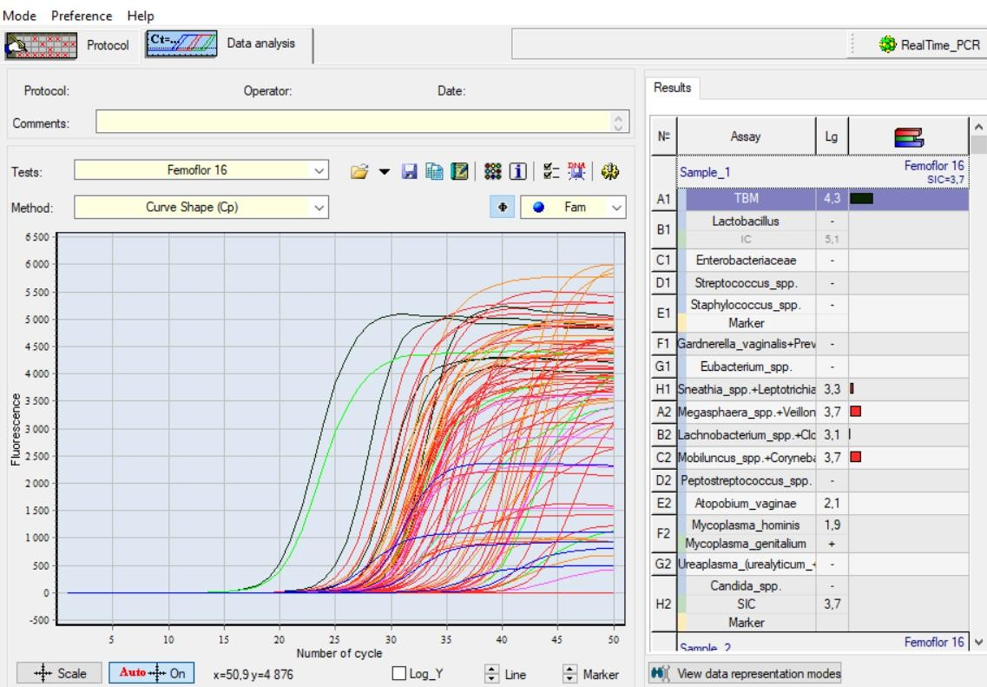
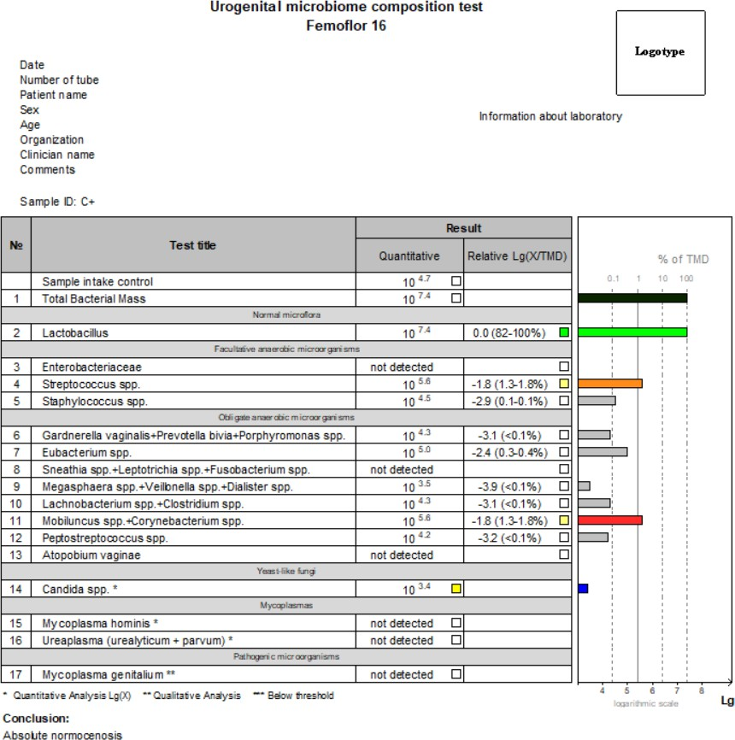
In case of using G-Quant Real Time PCR ThermoCylers, the analysis is performed automatically.
The quantitative measure (logarithm of concentration) and diagram are displayed in the line with taxonomic identifier of bacteria detected by Femobiome 16 Multiplex qPCR Kit.
In the samples free of specific product DNA, the Real-time PCR thermal cycler registers the expressed growing fluorescence of the internal control and its absence for the specific product.
In the absence of specific signal and IC signal the program registers unreliable result. It is necessary to repeat the analysis for the given sample. An unreliable result may be due to the presence of inhibitors in the DNA preparation; incorrect implementation of the analysis protocol, violation of the amplification temperature regime, etc. In this case, it is necessary to repeat PCR amplification, or DNA isolation and PCR, or sampling procedure for the given patient (performed sequentially).
When SIC value is lower than 4.0, it should be considered as insufficient amount of human DNA in sample and the sampling procedure must be repeated.
For positive control samples, the program registers a positive result. When negative results are obtained, all results of corresponding experiment should be considered as false. All samples must be reanalyzed.
For negative control samples, the program registers a negative result. When positive results are obtained, all results of the corresponding experiment should be considered as false and the PCR laboratory must be decontaminated.
V. RESULTS AND PERFORMANCE
22. | Article 20.4.1(q) | Analytical Performance Data
23. | Article 20.4.1(q) | Clinical Performance Data

a. The specificity of the Femobiome 16 Multiplex qPCR Kit was assessed by bioinformatics analysis using available on-line databases with up-to-date comprehensive genetic information. The specific oligonucleotides used in the test were checked against GenBank database sequences. None of the sequences showed sufficient similarity for unspecific detection.
The samples with specific product DNA are to be registered positive for specific product (a fragment of the specific product genome). The samples free of specific product DNA are to be registered negative for specific product and positive for internal control.
The lists of microorganisms identified by the kit are presented in Table 5.
№ of tube  in a strip | Dye label/detection channel
 | Fam | Hex | Rox
Strip-1
1 | Total bacterial load (TBL) | - | -
2 | Lactobacillus spp. | IC | -
3 | Enterobacteriaceae | - | -
4 | Streptococcus spp. | - | -
5 | Staphylococcus spp. | - | Marker
6 | Gardnerella vaginalis/Prevotella bivia/ Porphyromonas spp. | - | -
7 | Eubacterium spp. | - | -
8 | Sneathia spp./Leptotrihia spp./ Fusobacterium spp. | - | -
Strip-2
1 | Megasphaera spp./Veilonella spp./ Dialister spp. | - | -
2 | Lachnobacterium spp./Clostridium spp. | - | -
3 | Mobiluncus spp./Corynebacterium spp. | - | -
4 | Peptostreptococcus spp. | - | -
5 | Atopobium vaginae | - | -
6 | Mycoplasma hominis | Mycoplasma genitalium | -
7 | Ureaplasma (urealyticum + parvum) | - | -
8 | Candida spp. | SIC | Marker
Table 5: The list of microorganisms identified by the Femobiome 16 Multiplex qPCR Kit.
b. In a determination of analytical sensitivity, the Femobiome 16 Multiplex qPCR Kit demonstrated the ability to reproducibly detect 5 or more copies of purified pathogens DNA per PCR reaction. The copy number of the pathogens was determined by Poisson analysis.
The Femobiome 16 Multiplex qPCR Kit detects one CFU of the pathogen per PCR reaction. This analytical sensitivity was determined by serially diluting pathogens infected cultures in culture transport media. Samples of each dilution were processed and tested by the standard Kit procedure. Each of the replicates containing 1 CFU per amplification reaction gave a strong positive signal.
Analytical sensitivity is no more than 10000 copies/mL.
c. Diagnostic characteristics
Diagnostic sensitivity: 97%.
Diagnostic specificity: 97%.
The claimed specifications are guaranteed when DNA extraction is performed with PREP-NA PLUS DNA/RNA Extraction Kit.
V. RESULTS AND PERFORMANCE
24. | Article 20.4.1(m) | Retesting Requirements

 | Result | Possible cause | Solution
C+ | - | Operation error  PCR inhibition  Violation of storage and handling requirements | Repeat whole test  Dispose current batch
C- | + | Contamination | Dispose current batch  Perform decontamination procedures
IC | Invalid | PCR inhibition | Repeat whole test Resample

VI. ADDITIONAL INFORMATION
25. | Article 20.4.1(t) | Disposal of Used Materials

Amplification products must be handled in such a way as to reduce dispersion into the environment as much as possible, in order to avoid the possibility of contamination. Pipettes used to handle amplification products must be exclusively employed for this specific purpose.
Remove PCR waste only in a closed form. Do not open the tubes after amplification. Waste materials are disposed of in accordance with local and national standards. All surfaces in the laboratory (work tables, test tube racks, equipment, etc.) must be treated daily with disinfecting solution.

VI. ADDITIONAL INFORMATION
26. | Article 20.4.1(x) | Revision Date of Instructions for Use

VI. ADDITIONAL INFORMATION
27. | Article 20.4.1(v) | Standards with which Compliance is Claimed

ISO 15223-1, ISO 18113 Reference to relevant standards such

VI. ADDITIONAL INFORMATION
28. | Article 20.4.1(r) | Check Before Use

Do not use the kit:
- When the transportation and storage conditions are breached;
- When the reagents’ appearance does not respond to the kit passport;
- When the kit components packaging is breached;
- After the expiry date provided.
Significant health effects are NOT anticipated from routine use of this kit when adhering to the instructions listed in the current manual.
Only personnel trained in the methods of molecular diagnostics and the rules of work in the clinical and diagnostic laboratory are allowed to work with the kit.

VI. ADDITIONAL INFORMATION
29. | Technical Support Contact

For technical support, please contact our dedicated technical support team by email: support@genomer.com.tr or Phone: +90 530 462 2637.
VII. SYMBOLS/PICTOGRAMS

 | In vitro diagnostic medical device |  | Date of manufacture
 | Temperature limit |  | Consult instructions for use
 | Contains sufficient for  <n> tests |  | Catalogue number
 | Use-by date |  | Manufacturer
 | Batch code |  | Keep away from sunlight
 | Caution |  | Version
 | Positive control |  | Non-sterile
 |  |  | Do not reuse

REVISION HISTORY
Revision No. | Rev. Date | Description
00 | 14.11.2025 | First Issue

DOCUMENT APPROVAL
Prepared By | Approved By
Quality Management Representative | General Manager
Elife ÖZDEMİR | Oktay ÖZTÜRK

